Computer Graphics Assignment 3: OBJ Viewer

2014005014

컴퓨터전공

이 지민

1. How to run program

There is only main.py source file. So, open this file to execute OBJ viewer program.

2. Analysis of the program

1) Manipulation camera

・Key 1 & 3: rotate the camera about y axis

・Key 2 & W: translate the camera along the y axis

・Key A & S: zoom in and zoom out

These are implemented by using gluLookAt, gluPerspective functions. Increasing the field of view angle in degrees makes effect of zoom out. In the same way, decreasing the angle makes effect of zoom in.

2) Loading an obj file

To load an obj file, you should open the obj file by drag-and-drop to viewer window. This feature is implemented by using glfwSetDropCallback function. Firstly, it gets the filename through glfwSetDropCallback and open it. Read the contents of the file and save each information (vertex positions, vertex normals, faces information). Face information can be separated into three. First is vertex index. Second is texture index. Third is normal index. This program ignores texture coordinate, material, group, shading information.

3) Rendering an obj file

Render with polygon mesh based on loaded data using glNormal, glVertex functions.

4) Toggling wireframe / solid mode

The program can toggle modes by pressing z key. If mode is wireframe mode, change the polygon mode to GL_FRONT_AND, GL_LINE. If mode is solid mode, change the polygon mode to GL_FRONT_AND_BACK, GL_LINE.

5) Printing information of the obj file

Print the following information each time the obj file is opened.

6) Lighting configuration

Using three light sources (GL_LIGHT0, GL_LIGHT1, GL_LIGHT2)

・ GL_LIGHT0

- lightPosition: (1.,2.,3.,1.)

- ambientLightColor: (.1,.1,.1,1.)

- diffuseLightColor: (1.,1.,1.,1.)

- specularLightColor: (1.,1.,1.,1.)

・ GL_LIGHT1

- lightPosition: (0.,0.,1.,0.)

- ambientLightColor: (.1,.1,.1,1.)

- diffuseLightColor: (.1,.1,.1,1.)

- specularLightColor: (.1,.1,.1,1.)

・ GL_LIGHT2

- lightPosition: (1.,0.,0.,1.)

- ambientLightColor: (.5,.5,.5,1.)

- diffuseLightColor: (.5,.5,.5,1.)

- specularLightColor: (1.,1.,1.,1.)

3. Screenshot images of obj file

Image1(solid mode and wireframe mode)

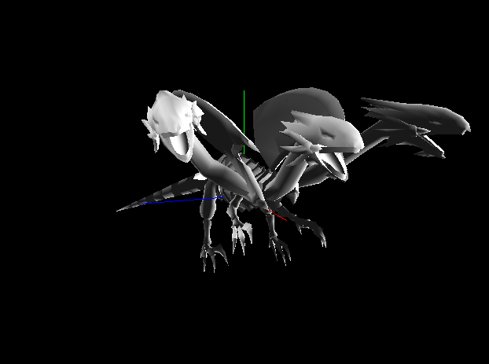 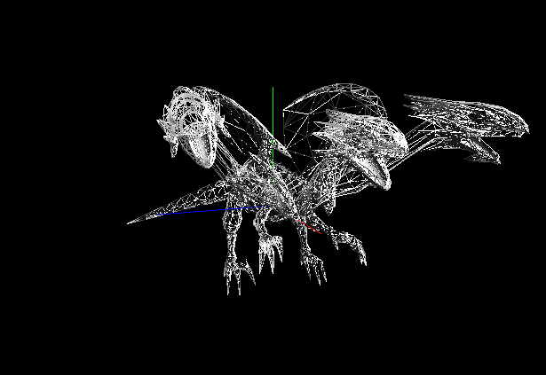

Image2(solid mode and wireframe mode)

